To: Prof. Yu DU

From: Arpit Agarwal, Avi Manawat, Puneet Kochar

Subject: Help Desk staffing

Date: 9/24/2019

Some Employees at Help Desk complain they are overworked and need help; others say there’s little to do during their shift so their time could best be spent on other assignments.

**EXECUTIVE SUMMARY**

**Major Findings:**

* We found that the data has some negative values which we have considered as positive values, as number of calls cannot be negative.
* Tuesday was recorded in the dataset as both ‘tue’ and ‘tues’, so in order to bring uniformity, we changed all days to their respective full names.

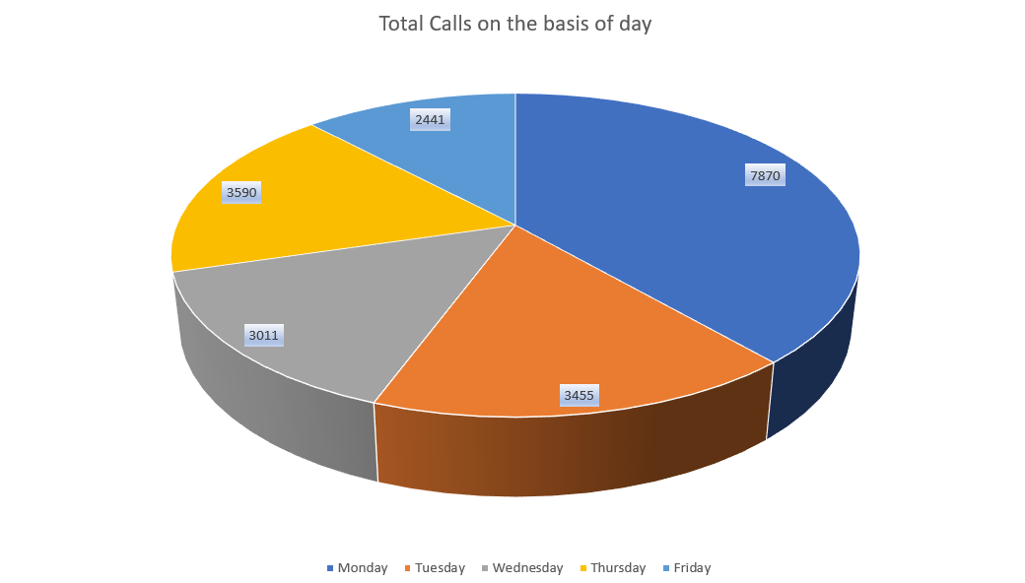

* Observing pie chart, the highest call traffic is on Monday, while the least traffic is on Friday.

* Maximum call traffic is observed during 6 a.m. - 4 p.m. while the least between 10 p.m.-2 a.m.

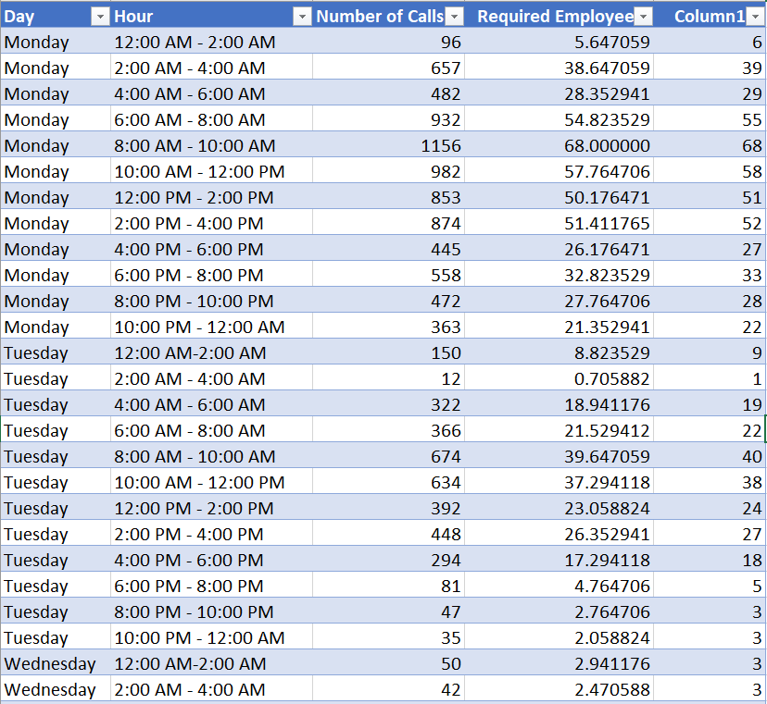

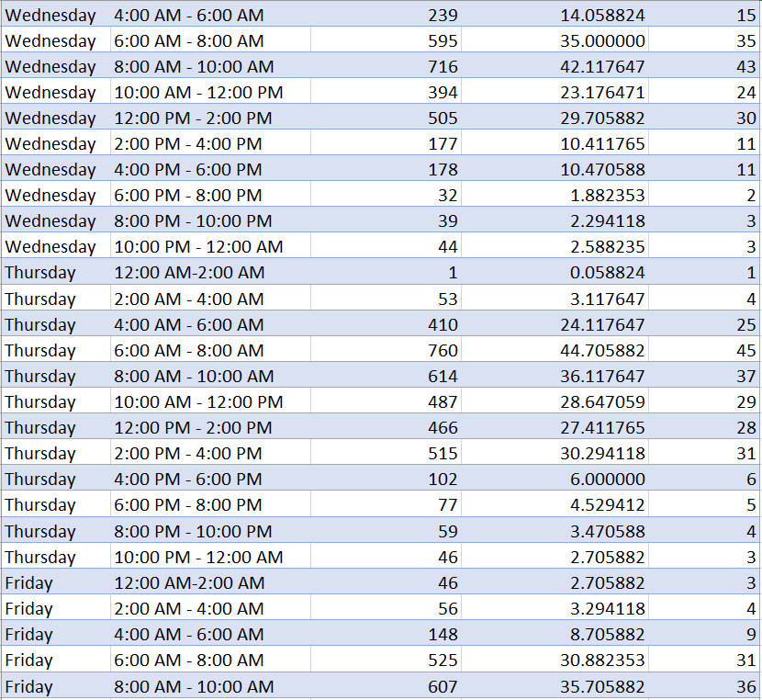

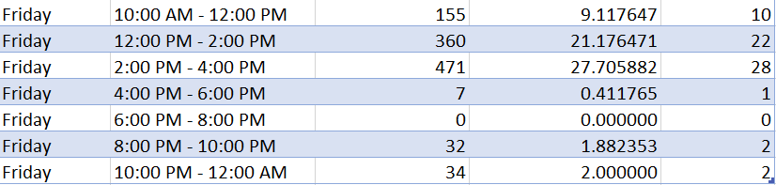

**Recommendations:**

* We can divide the employee shifts in two categories: Peak, Low.

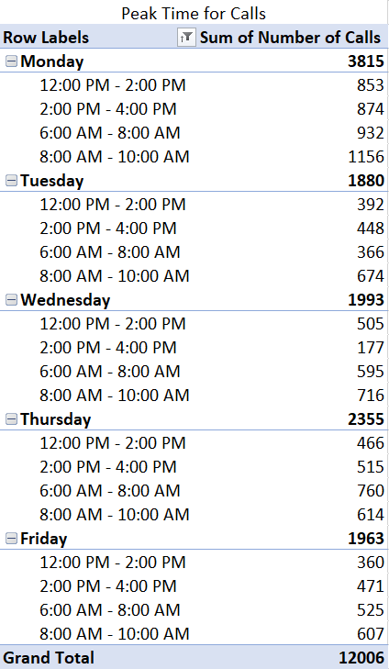

* The highest traffic is between 6 a.m. – 4 p.m., considering it as the peak shift. We recommend management to assign these shifts to full time employees of the company.
* The shifts after 4 p.m. for all days have low number of incoming calls, therefore management can hire part time workers for these shifts.
* No calls have been received on Friday between 6 p.m. – 8 p.m. but as our help desk is 24x7, atleast 1 full time employee should be at the desk.

**Analytical Overview:**

* For each day, we prepared a pie chart that implies total number of calls on each day.
* To find the call traffic for hourly shifts, we plotted a bar graph and pivot (Appendix Figure 1) representing the traffic in each shift for all days.
* Given the average calls/employee/two-hour shift is 17, thus prepared a table to find required number of employees in each shift.